

**CPAT Audit Reports**

QlikView Detailed Design Document

**<Version No. 1.1>**

Detailed Design Description

Signatures below indicate agreement and/or approval of the contents of this detailed design description. The author and approver names and functions are to be identified in the change documentation (e.g., change number) or project plan.

|  |  |  |
| --- | --- | --- |
| Document Prepared By: | | |
| Name and Function | Signature | Date |
| Indhumathi Sanmugam, Developer- Cognizant technology Solutions | SI | 11/27/2013 |
| Prabhu Appu, Developer- Cognizant technology Solutions | AP | 12/05/2013 |

|  |  |  |
| --- | --- | --- |
| Document Reviewed By: | | |
| Name and Function | Signature | Date |
| Tushar Firke | TF |  |
|  |  |  |
|  |  |  |

| Document Approvals : | | |
| --- | --- | --- |
| Name and Function | Signature | Date |
|  |  |  |
|  |  |  |
|  |  |  |

|  |  |  |  |
| --- | --- | --- | --- |
| Revision History: | | | |
| Document Version Number | Document Revision Date | Written By | Change Summary  (Reference section[s] changed) |
| 1.0 | 09/11/2013 | Indhumathi Sanmugam | Document Created |
| 1.1 | 12/05/2013 | Prabhu Appu | Updated the Actions and Triggers used in sheets |
|  |  |  |  |
|  |  |  |  |
|  |  |  |  |
|  |  |  |  |
|  |  |  |  |
|  |  |  |  |
|  |  |  |  |
|  |  |  |  |
|  |  |  |  |

Contents

1.0 Introduction 5

1.1. Purpose 5

1.2. Scope 5

1.3. System Design Constraints 5

1.4. Acronyms and Definitions 6

2.0 System Design 6

2.1 Background 6

2.2 High Level System Architecture 6

3.0 Data Structure 9

3.1 Fact Table 10

3.2 Dimension Table 10

3.2 Server Details 11

3.3 Database Source 11

3.4 Qlikview Vs. database field Mapping 12

4.0 User Interface 12

4.1 Introduction 12

4.2 Input Reports 13

4.3 Input Validations 14

4.4 Output Reports 16

4.5 Output Counts and validations 17

4.6 Variables Used 18

4.7 Actions and Triggers 18

5.0 Folder Structure 19

6.1 QVD and QVW Reload 20

6.2 Application Refresh 20

7.0 Security Model 20

# Introduction

## Purpose

The document covers the implementation of all the QlikView components, the underlying extraction scripts and implementation of CPAT Audit reports.

The intended audience of this document is the application development team, client IT team, application and database administration team. This document provides the detailed guidelines for implementing all the identified modules.

This document is organized into various sections describing the system flow, system modules and detailed design of all the system modules.

## Scope

This design document covers the design aspect of the CPAT Audit reports pertaining to:

* QlikView front end to be created to represent the CPAT Audit application.
* QlikView QVD file structure to contain the data required to populate the front end
* Workflow for creation of QVD documents as part of the semi-automated process

## System Design Constraints

1. The browser recommended for this application is IE with cookies enabled. The application will be tested on IE browser.
2. The application will be available only within the Abbvie Intranet through VPN Client.
3. Authentication will be Single Sign-on / Auto login.
4. The QlikView documents developed use a single language (English US).
5. The QlikView documents developed use a single time zone (US Central Time).
6. The User interface is implemented based on the guidelines specified in http://www.abbvie.com/
7. The QlikView Server Build, QlikView Publisher and QlikView Client are Version 11 of QlikView.

## Acronyms and Definitions

|  |  |
| --- | --- |
| Acronym | Definition |
| BI | Generic term for Business Intelligence and should refer to QlikView 11 software program |
| QVW | QlikView Application Files |
| QVD | QlikView Data file type |
| QMC | QlikView Management Console |
| CPAT |  |

# System Design

## Background

CPAT Audit reports used to validate/ check the accuracy of the ETL and iAlign CPAT data. Quarterly reports are generated to track the correctness.

## High Level System Architecture

The following diagram illustrates the high level system architecture of the Application.

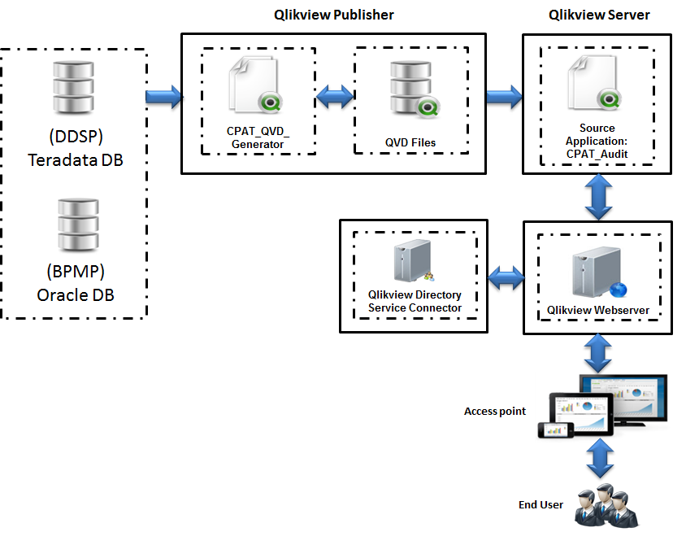

**Source Database:**

Following tables are used to build the application.

**Database**:

* DDSP – ETL Source system
* BPMP – iAlign Source system

**Tables**:

DDSP

* AUDIT_CPAT
* AUDIT_DETAIL_ETL

BPMP

* T_OUTPUT_VALIDATIONS
* DI_OUTPUT_REPORT
* DI_AUDIT_SUMMARY
* TERRITORY_PHYSICIAN_CNT_TGT, TERRITORY_PHYSICIAN_CNT_NONTGT
* DI_AUDIT_SUMMARY_DETAILS

**QVD generator:**

QVD_Generator_CPAT.qvw

* ETL Summary tables and iAlign summary tables are concatenated and the CPAT_SUMMARY.qvd created.
* ETL detailed tables and iAlign detailed tables are concatenated and the CPAT_DETAIL.qvd created.

<<<For more details refer mapping document section – 3.5 >>>

**Source Application:**

CPAT_Audit.qvw

* CPAT_SUMMARY.qvd is loaded into CPAT_Audit.qvw, CPAT_SUMMARY table has been created.
* CPAT_DETAIL.qvd is loaded into CPAT_Audit.qvw, CPAT_ DETAIL table has been created.
* CPAT_SUMMARY and CPAT_DETAIL tables Joined with the join key Audit_Check
* CPAT_CHECK table having the check id and check name which is joined with CPAT_SUMMARY table by join key Audit_ID
* User interface has been created with the Qlikview chart object.

***Teradata Database:*** ETL and source data has been loaded from Teradata databases DDSP.

***Oracle Database:*** iAlign data has been loaded from Teradata databases BPMP.

***QVD files***: The QVD files are data extracts from the flat files for the QlikView application.

***QVW files***: The QVW files define the transformation and front end for a QlikView application

**QlikView Publisher (QVP):** QlikView Publisher will be used to reload the QVD and the QVW files when new data needs to be refreshed and distribute to the QlikView Server.

***QlikView Server (QVS)***: The QlikView documents will be deployed in the QlikView Server. QlikView Server handles the communication between clients and the QlikView applications.

|  |  |
| --- | --- |
| **Tab Name** | **Description** |
| Introduction | This tab provides the General information about CPAT Audit application. |
| Input Reports | These reports will display the Input count for Source, ETL and iAlign CPAT data. The summary report will show overall counts at various stages of process – Source, ETL and iAlign. The detailed report will show the territory wise counts. The user is allowed to filter the data by sales group and selling period |
| Input Validations | These reports will display the count for each audit check for Source, ETL and iAlign data. Clicking on the count will give the list of exceptions. The user is allowed to filter the data by sales group and selling period. Roster report will give details of counts and exceptions w.r.t roster data. Classification report will give details of counts and exceptions w.r.t classification data. |
| Output Reports | These reports will display the output counts from iAlign CPAT tool. The first report will give the summary of Total targets and Total Calls. The detailed report will show the territory wise count of Targets and Calls. The user is allowed to filter the data by sales group and selling period. |
| Output Counts and validations | These reports will display the counts and audit checks for Outbound iAlign CPAT data. Clicking on the validation counts will get the detailed report. The user is allowed to filter the data by sales group and selling period. |

# 3.0 Data Structure

The following diagram indicates the data structure used for the CPAT Audit reports.

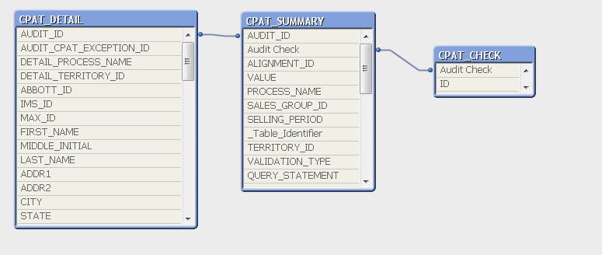

## 3.1 Fact Table

CPAT_SUMMARY

     Audit Check   
     TERRITORY_ID   
     ORIGINAL   
     DROPS  
     DROP_PERCENTAGE   
     RETAINED   
     RETAINED_PERCENTAGE   
     ADDED  
     ADDED_PERCENTAGE   
     PROPOSED   
     SALESGROUP_ID   
     SELLING_PERIOD  
     HEADER_ID

VALIDATION_COUNT  
     VALIDATION_TYPE  
     VALIDATION_ID

## 3.2 Dimension Table

CPAT_DETAIL

  AUDIT_ID  
     PROCESS_NAME  
 TERRITORY_ID  
     ABBOTT_ID   
     IMS_ID   
     MAX_ID   
     FIRST_NAME   
     MIDDLE_INITIAL   
     LAST_NAME   
     ADDR1  
     ADDR2   
     CITY  
     STATE   
     ZIP   
     ABS_SPECIALTY_ID   
     PRODUCT1_NAME  
     PRODUCT1_CALLS   
     PRODUCT1_CALLS_TYPE  
     PRODUCT2_NAME   
     PRODUCT2_CALLS   
     PRODUCT2_CALLS_TYPE  
     PRODUCT3_NAME   
     PRODUCT3_CALLS   
     PRODUCT3_CALLS_TYPE  
     PRODUCT4_NAME  
     PRODUCT4_CALLS   
     PRODUCT4_CALLS_TYPE  
     TEAM_ID   
     CAMPAIGN_PERIOD   
     CAMPAIGN_YEAR   
     DATA_SOURCE  
     TERRITORY_TYPE_ID   
     FRANCHISE_ID  
     EMPLOYEE_ID   
     OPEN_TERRITORY   
     CLASSIFICATION_COLUMN   
     CLASSIFICATION_NAME   
     CLASSIFICATION_TYPE   
     CLASSIFICATION_SEGMENT_ID   
     REJECT_REASON

CPAT_CHECK

CHECK ID   
CHECK NAME

## 3.2 Server Details

The following are the details of the server which we are used for this application.

**Server Name**: ppdwp1 (Production)

**Databases**: DDSP

**Server Name**: bpmd.oneabbott.com

**Databases**: BPMP

## 3.3 Database Source

Following table provides the description of each table used in the CPAT Audit reports:

|  |  |  |
| --- | --- | --- |
| **Database Name** | **Table Name** | **Description** |
| DDSP | AUDIT_CPAT | This table contains the ETL/Source Summary data(Count for each check) |
| AUDIT_DETAIL_ETL | This table contains the ETL/Source Detailed data |
| BPMP | T_OUTPUT_VALIDATIONS | This table contains the detailed data for Output Validations report |
| DI_OUTPUT_REPORT | This table contains the Summary data for Input Validations report |
| DI_AUDIT_SUMMARY | This table contains the detailed data for Input Validations report |
| TERRITORY_PHYSICIAN_CNT_TGT | This table contains the data for Input report for call plan |
| TERRITORY_PHYSICIAN_CNT_NONTGT | This table contains the data for Input report for Non call plan |
| DI_AUDIT_SUMMARY_DETAILS | This table contains the detailed data |

## 3.4 Qlikview Vs. database field Mapping

This section shows the mapping between DDSP tables against the Qlikview fields,

# 4.0 User Interface

This section contains indicative screen designs for the QlikView front end.

* Introduction
* Input Reports
* Input Validations
* Output Reports
* Output Counts and validations

## 4.1 Introduction

This tab provides the General information about the CPAT Audit reports.

## 4.2 Input Reports

These reports will display the Input count for Source, ETL and iAlign CPAT data. The summary report will show overall counts at various stages of process – Source, ETL and iAlign. The detailed report will show the territory wise counts. The user is allowed to filter the data by sales group and selling period.

|  |
| --- |
|  |
|  |

vColumn2 - Change the color of the text in the column 2 if it is not equal to the value in the previous column

vColumn3 - Change the color of the text in the column 3 if it is not equal to the value in the previous column

vColumn5 - Change the color of the text in the column 5 if it is not equal to the value in the previous column

vColumn6 - Change the color of the text in the column 6 if it is not equal to the value in the previous column

vColumn8 - Change the color of the text in the column 8 if it is not equal to the value in the previous column

vColumn9 - Change the color of the text in the column 9 if it is not equal to the value in the previous column

vColumn11 - Change the color of the text in the column 11 if it is not equal to the value in the previous column

vColumn12 - Change the color of the text in the column 12 if it is not equal to the value in the previous column

vColumnFmt_2 - Change the color of the text in the column 2 if it is not equal to the value in the previous column

vColumnFmt_3 - Change the color of the text in the column 3 if it is not equal to the value in the previous column

vColumnFmt_5 - Change the color of the text in the column 5 if it is not equal to the value in the previous column

vColumnFmt_6 - Change the color of the text in the column 6 if it is not equal to the value in the previous column

vColumnFmt_8 - Change the color of the text in the column 8 if it is not equal to the value in the previous column

vColumnFmt_9 - Change the color of the text in the column 9 if it is not equal to the value in the previous column

vColumnFmt_11 - Change the color of the text in the column 11 if it is not equal to the value in the previous column

vColumnFmt_12 - Change the color of the text in the column 12 if it is not equal to the value in the previous column

**Actions**:

* Action is set on the Summary button to set the variable ***vInput*** = ‘Summary’
* Action is set on the Detail Button to set the variable ***vInput*** = ‘Detail’
* If ***vInput***=’Summary’ then summary table will be shown
* If ***vInput=’Detail’*** then Detail report will be shown
* Summary tables show the ***Audit checks*** which are having the ID value 1 or 2 or 3.
* Detail Table show the Audit checks which are having the ID value 4
* The cell is Highlighted Red if column (n) is not equal to column (n-1) within each section – Call Plan, Next Best & Non Call Plan. For ex within Call Plan for Total Records, if ETL Call Plan <> Source Call Plan then highlight that cell in red. Similarly within Non Call Plan for Total Records, if iAlign Call Plan <> ETL Call Plan then highlight that cell in red (for both detail and Summary tables)

**Triggers:**

* Sheet level Trigger is enabled to set the variable value vInput =’Summary’ on activating the sheet

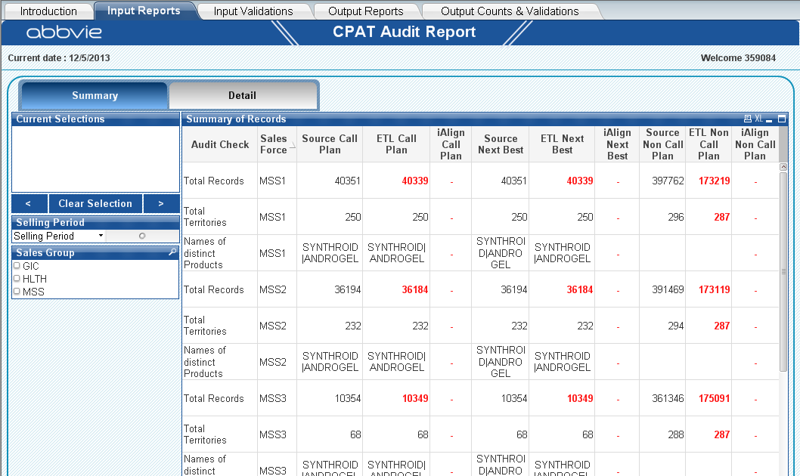

Click on the detail button to view the detailed report which will show the count for each territory.

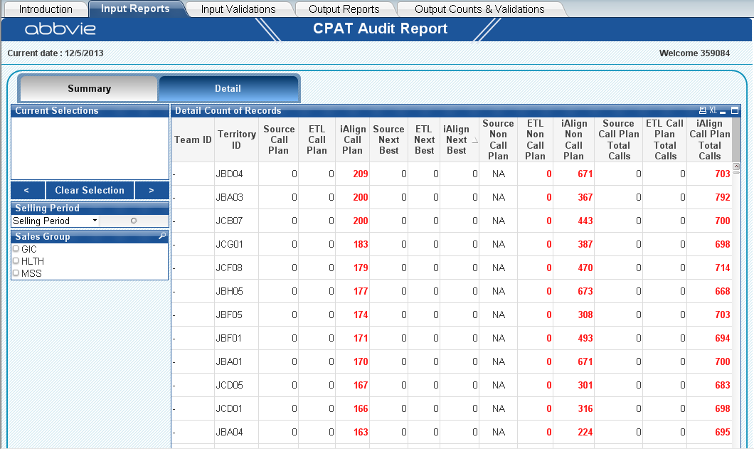

## 

## 4.3 Input Validations

These reports will display the count for each audit check for Source, ETL and iAlign data. Clicking on the count will give the list of exceptions. The user is allowed to filter the data by sales group and selling period. Roster report will give details of counts and exceptions w.r.t roster data. Classification report will give details of counts and exceptions w.r.t classification data.

Actions:

* Action is set on the HCP Universe button to set the variable ***vValidations*** = ‘HCP’
* Action is set on the Roster button to set the variable ***vValidations*** =’Roster’
* Action is set on the Classification button to set the variable ***vValidations*** =’Class’
* If ***vValidations*** = ‘HCP’ then HCP Universe table will be shown
* If ***vValidations*** =’Roster’ then Roster Information table will be shown
* If ***vValidations*** =’Class’ then Classification table will be shown
* When the user clicks on a count, the detailed report will be shown for that particular Checks
* The variable vdetail will be set to 1 when the selected count of audit check is 1
* Detail report will be if the variable value vdetail=1
* HCP Universe tab shows the ***Audit checks*** which are having the ID >5 and <26
* Roster tab –Roster Information table shows the ***Audit checks*** which are having the ID >25 and <32
* Roster tab – Input data check shows the ***Audit checks*** which are having the ID >31 and <40
* Classification tab shows the ***Audit checks*** which are having the ID >39 and <44

**Trigger:**

* Sheet level Trigger is enabled to set the variable value vValidations =’HCP’ on activating the sheet

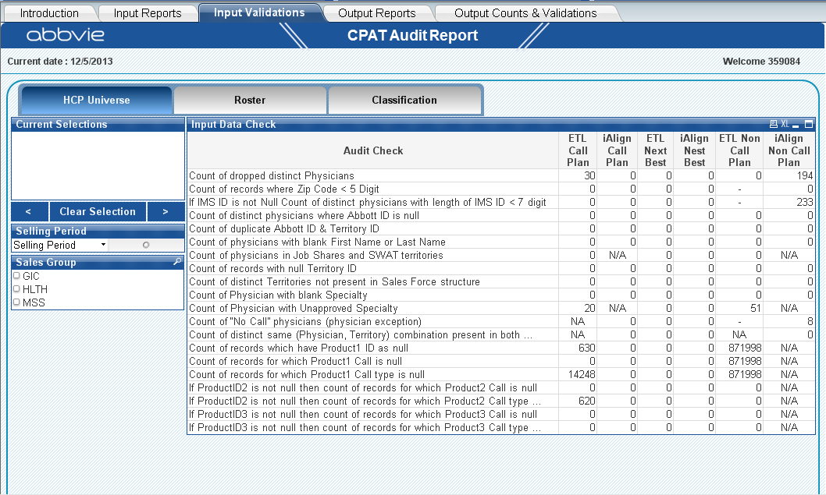

Clicking on the Roster button will navigate to roster report.

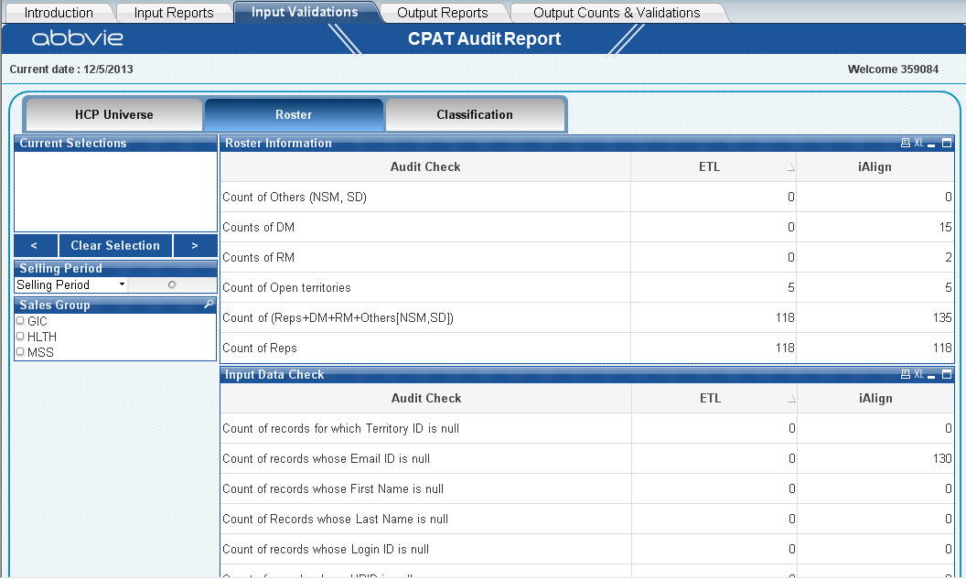

Clicking on the Classification button will navigate to classification report.

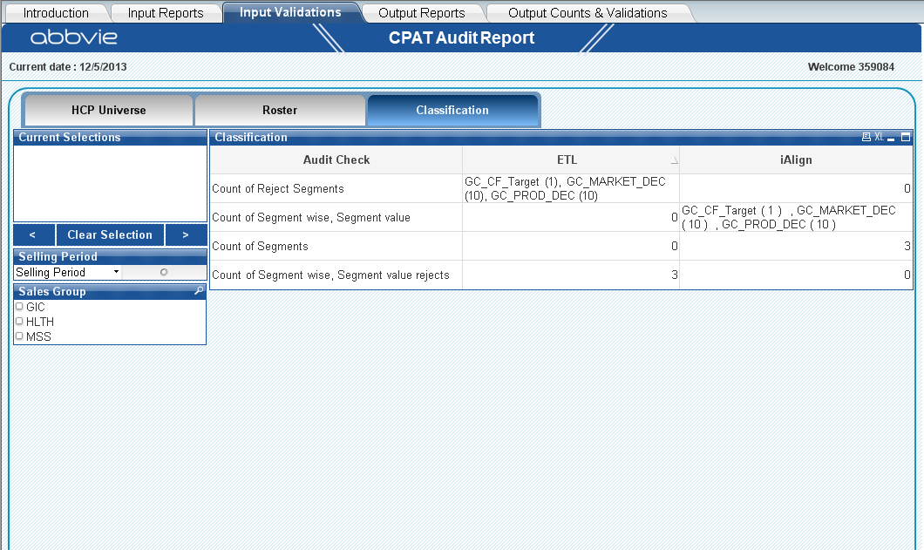

## 4.4 Output Reports

These reports will display the output counts from iAlign CPAT tool. The first report will give the summary of Total targets and Total Calls. The detailed report will show the territory wise count of Targets and Calls. The user is allowed to filter the data by sales group and selling period.

**Actions**:

* Action is set on the Target & Calls button to set the variable **vOutput** =’TGTCALLS’
* Action is set on the Territory Level Targets button to set the variable **vOutput** =’TGT’
* Action is set on the Territory Level Calls button to set the variable **vOutput** =’CALLS’
* If **vOutput** =’TGTCALLS’ then Physician Territory combinations and Total Calls table will be shown
* If **vOutput** =’TGT’ then Territory Level Targets table will be shown
* If **vOutput** =’CALLS’ then Territory Level Calls table will be shown
* In Physician Territory combinations table If (#Pre-Add/Drop - #Drops + #Retained + #Add) <> #Post Add/Drop then last row will be highlighted in Red
* In Territory Level Targets table If (#Pre-Add/Drop Targets - #Drops + #Retained + #Added) <> #Post Add/Drop Targets then that row in last column will be highlighted in Red
* In Territory Level Calls table If (#Pre-Add/Drop Calls - #Drops + #Retained + #Added) <> #Post Add/Drop Calls then that row in last column will be highlighted in Red

**Trigger:**

* Sheet level Trigger is enabled to set the variable value vOutput =’TGTCALLS’ on activating the sheet

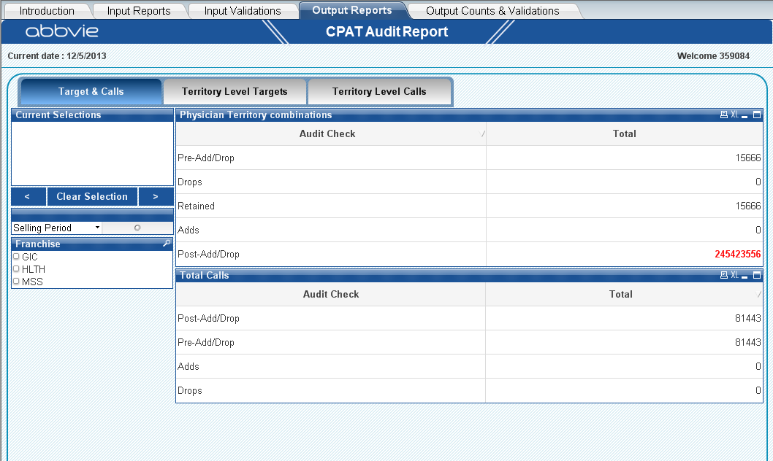

Clicking on the territory level target button will navigate to territory level target report which will show the targets for territory.

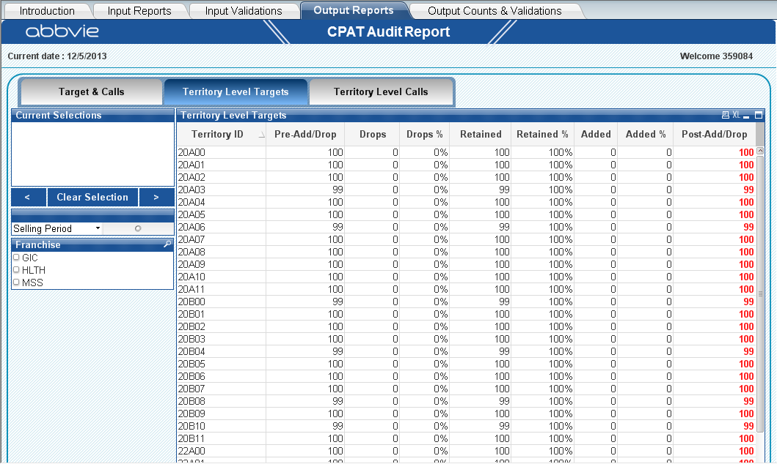

Clicking on the territory level calls button will navigate to territory level calls report which will show the targets for territory.

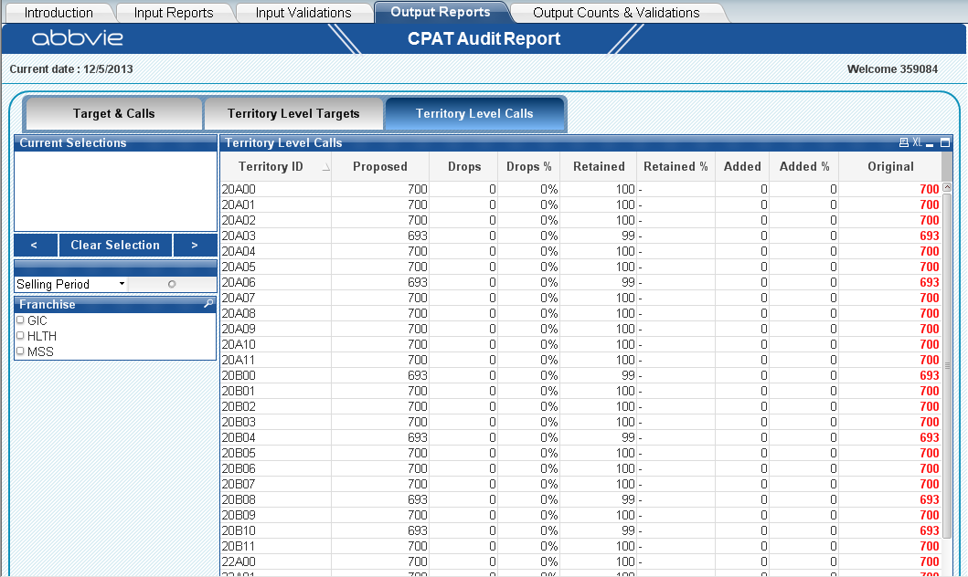

## 4.5 Output Counts and validations

These reports will display the counts and audit checks for outbound iAlign CPAT data. Clicking on the validation counts will get the detailed report. The user is allowed to filter the data by sales group and selling period.

**Actions**:

* Action is set on the Output Counts button to set the variable **vOutput_2** =’Counts’
* Action is set on the Output Validations button to set the variable **vOutput_2** =’Valid’
* If **vOutput_2** =’Count’ then Output Counts table will be shown
* If **vOutput_2** =’Valid’ then Output Validations table will be shown

**Trigger:**

* Sheet level Trigger is enabled to set the variable value vOutput_2 =’Counts’ on activating the sheet

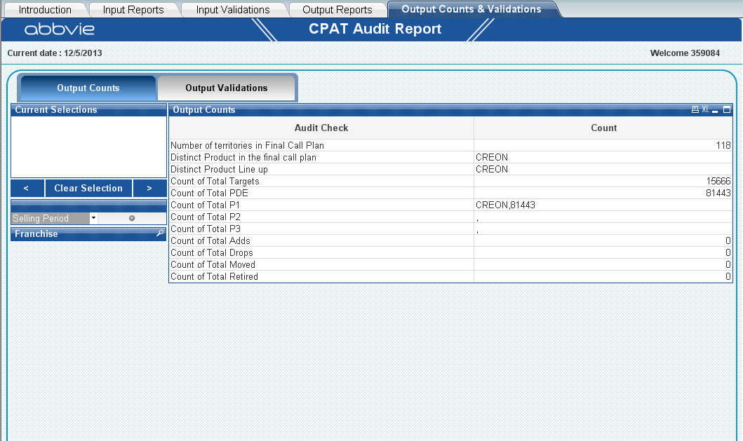

Clicking the output Validation button will navigate the validation report. this validation report shows the check counts for ialign data.

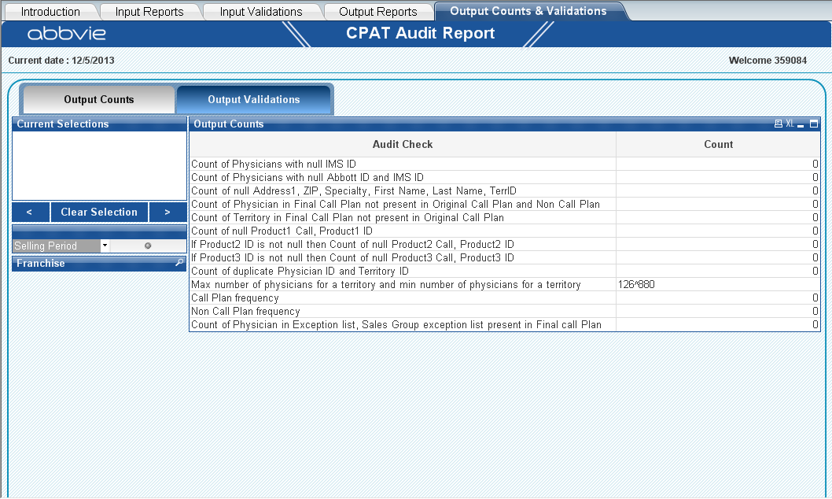

## 4.6 Variables Used

The following are the variables which are used in the application.

* vSelectedCheck - To show the detailed report for the selected check
* VInput - To show the summary details in the input report
* vOutput - To show the summary details in the output report

<<Will update this section during development phase>>

## 4.7 Actions and Triggers

The following are the actions which we are used in our application.

* Clear Selections-Action is set to clear all the fields which are selected.
* Forward-Action is set to show the previous selection
* Backward-Action is set to show the backward selection. All the clear options are at Sheet level.
* Print-Action is set to print the particular sheet. It’s at Sheet level.
* BACK is used to navigate the user from the detailed table to home page.

<<Will update this section during development phase>>

# 5.0 Folder Structure

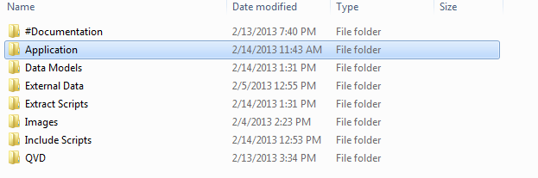

**Folder structure for CPAT Audit reports**

* #Documentation –
* Documentation specific to HLink Analytics App
* System Administration (files created by QlikView Server and Publisher for system logging, performance monitoring, etc.)

▪ Log Files

* Application

QlikView Documents – the QVW and related files that make up the QlikView application.  These are the End User Documents (the reloaded source documents published for users to consume).

* Data Models

Data model information for the application, used to integrate QVD and other data to create the data model.

* External Data

Other Data (not QVD files) - Spreadsheets, other data source files - xls, csv, or any other type of data.

* Extract Scripts

Base QVW: Raw data extracted from the data source is loaded into Qlikview and store it into a QVD.

* Images

Images used for the QlikView application (Country flags, Abbvie logos, etc.)

* Include Scripts

Include Scripts folder contains Connection String Details which will be used in the application for different environments.

* QVD

QVD folder contains Base QVD which stores the QVD’s which are created by the respective QVW’S.

## 6.1 QVD and QVW Reload

Qvd is refresh is done in two ways,

* Full load – will load the entire data to qvd
* Incremental load – loading old data from the QVD and new records from the database and combine into single QVD.

We will be creating two different applications. One is for full load another one is for incremental load. The incremental load is done by Quarterly basic.

Qvd loads,

* First time load will be full load
* Next time we will be loading the data by incremental logic
  + For ETL data CREATED_DATE and MODIFIED_DATE columns are used to implement the incremental logic
  + For iAlign Data SELLING_PERIOD is used to implement the incremental load

## 

## 6.2 Application Refresh

Occurs when the Data model task ran successfully

* The Application refreshes the data from the QVD.
* The application is distributed to the respective users.

# 7.0 Security Model

Security model is a scheme for specifying and enforcing security policies. A security model may be founded upon a formal model of access rights.

User authentication takes place from the active directory group comprising of all the end users.

There is no data level security being enforced upon currently. All authenticated users are allowed to view the dashboard with the entire data loaded and no data reductions.

<<Need to update>>